|  |  |  |  |
| --- | --- | --- | --- |
| **Name of Student: NINAD AVINASH PATIL** | | | |
| **Roll No: 33** | | **Lab Practical Number: 3(A).2** | |
| **Title of Lab Practical: Write a program that asks the user for the name of the text file. The program should display the first 10 lines of the file on the screen. If the file has fewer than 10 lines the entire file should be displayed along with the msg indicating the entire file has been displayed.** | | | |
| **DOP: 19/03/2021** | | **DOS: 24/03/2021** | |
| **CO Mapped: CO1** | **PO Mapped: PO3, PO5, PO7,**  **PO12, PSO1, PSO2** | **Faculty Signature:** | **Marks:** |

**Practical No 3(A).2**

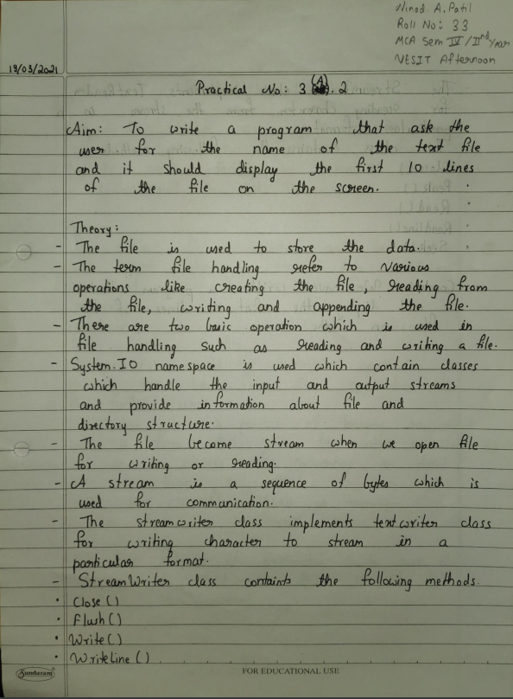

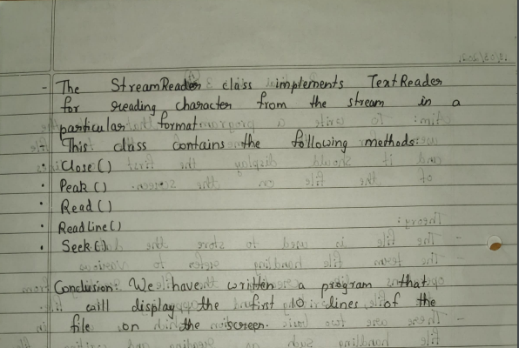

**Code:**

using System;

using System.Collections.Generic;

using System.ComponentModel;

using System.Data;

using System.Drawing;

using System.Linq;

using System.Text;

using System.Windows.Forms;

using System.IO;

namespace fileio

{

public partial class Form1 : Form

{

public Form1()

{

InitializeComponent();

}

private void button1_Click(object sender, EventArgs e)

{

string name = @"E:\" + textBox1.Text;

string[] lines = File.ReadAllLines(@name);

if(lines.Length <= 10)

{

for(int i = 0;i < lines.Length;i++)

{

richTextBox1.Text+=lines[i];

}

label3.Text = "Displaying complete file.";

}

else if(lines.Length>=10)

{

for(int i = 0;i < 10;i++)

{

richTextBox1.Text += lines[i];

}

label3.Text = "Displaying only 10 lines from the file.";

}

richTextBox1.Visible = true;

label3.Visible = true;

}

private void button2_Click(object sender, EventArgs e)

{

richTextBox1.Clear();

}

}

}

**Output:**

